

**COMP-SCI 5590 - 0002   Special Topics**

**Mobile App Development**

LAB 5: SQLite Database

Lesson Plan

SQLite is an open source SQL database that stores data to a text file on a device. Android comes in with built in SQLite database implementation. This exercise will help the programmers with implementing CRUD operations using SQLite using database.

In Class Exercise

1. Implement the delete contact feature into the address book source code provided in the class DBHelper.java

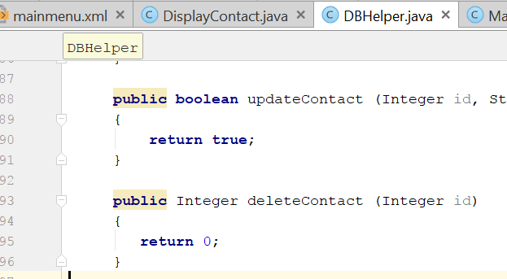

1. Add Edit Contact menu to res/menu folder/display_contact.xml

<item android:id="@+id/Edit_Contact"

android:orderInCategory="100"

android:title="@string/edit"/>

1. Add following code to DisplayContact.java at appropriate place.

case R.id.Edit_Contact:

Button b = (Button)findViewById(R.id.button1);

b.setVisibility(View.VISIBLE);

name.setEnabled(true);

name.setFocusableInTouchMode(true);

name.setClickable(true);

phone.setEnabled(true);

phone.setFocusableInTouchMode(true);

phone.setClickable(true);

email.setEnabled(true);

email.setFocusableInTouchMode(true);

email.setClickable(true);

street.setEnabled(true);

street.setFocusableInTouchMode(true);

street.setClickable(true);

place.setEnabled(true);

place.setFocusableInTouchMode(true);

place.setClickable(true);

return true;

1. Implement the updateContact feature



Submission Guidelines

* Submit Assignment on Github
* Make your own Github account and then make repository.
* Upload your code
* Then give a small description about it in wiki page of Github.
* Then Submit the code to UMKC BlackBoard using Turnitin.
* Remember similarity score should be less than 45%
* Commented code will earn you more extra points.